**ASSIGNMENT 5 :**

**1 . Maximum XOR of Two Non-Overlapping Subtrees** CODE : def first(arr, low, high, x, n):

if (high >= low):

mid = low + (high - low) // 2 # (low + high)/2 if ((mid == 0 or x > arr[mid-1]) and arr[mid] == x):

return mid

if (x > arr[mid]):

return first(arr, (mid + 1), high, x, n)

return first(arr, low, (mid - 1), x, n)

return -1

def sortAccording(A1, A2, m, n):

temp = [0] * m visited = [0] * m

for i in range(0, m): temp[i] = A1[i] visited[i] = 0

temp.sort()

ind = 0 for i in range(0, n): f = first(temp, 0, m-1, A2[i], m) if (f == -1): continue

j = f while (j < m and temp[j] == A2[i]): A1[ind] = temp[j] ind = ind + 1

visited[j] = 1 j = j + 1

for i in range(0, m):

if (visited[i] == 0): A1[ind] = temp[i] ind = ind + 1

def printArray(arr, n):

for i in range(0, n):

print(arr[i], end=" ")

print("")

A1 = [2, 1, 2, 5, 7, 1, 9, 3, 6, 8, 8]

A2 = [2, 1, 8, 3]

m = len(A1) n = len(A2) print("Sorted array is ") sortAccording(A1, A2, m, n) printArray(A1, m) OUTPUT:

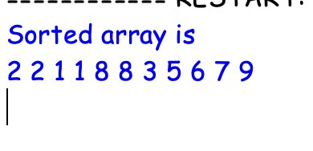

1. **. Form a Chemical Bond** CODE :

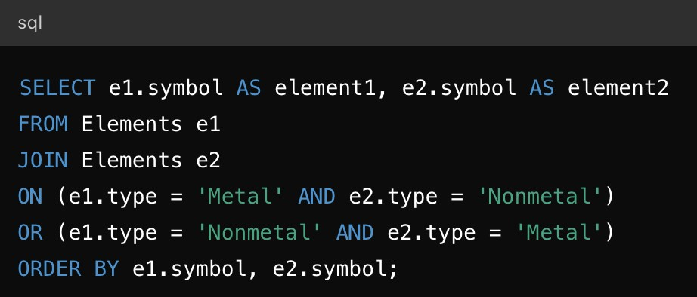

OUTPUT :

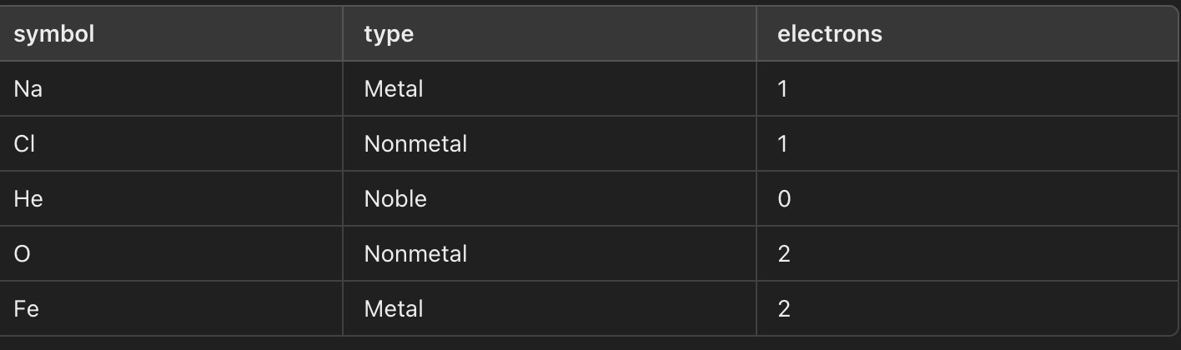

1. **. Minimum Cuts to Divide a Circle** CODE : class Solution: def numberOfCuts(self, n: int) -> int:

if n == 1:

return 0

elif n % 2 == 0:

return n // 2 else:

return n

solution = Solution() print(solution.numberOfCuts(1)) print(solution.numberOfCuts(2)) print(solution.numberOfCuts(3)) print(solution.numberOfCuts(4)) print(solution.numberOfCuts(5))

OUTPUT :

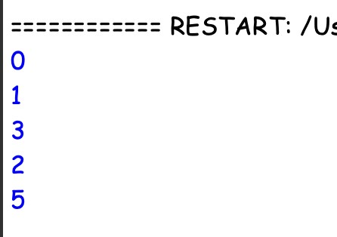

**4 . Difference Between Ones and Zeros in Row and Column** CODE : class Solution:

def differenceOnesZeros(self, matrix):

rows = len(matrix) cols = len(matrix[0]) row_diff = [0] * rows col_diff = [0] * cols for i in range(rows): ones = sum(matrix[i]) zeros = cols - ones row_diff[i] = ones - zeros

for j in range(cols): ones = sum(matrix[i][j] for i in range(rows))

zeros = rows - ones

col_diff[j] = ones - zeros

return row_diff, col_diff

solution = Solution() matrix = [

[1, 0, 1],

[0, 1, 1],

[1, 1, 0]

]

row_diff, col_diff = solution.differenceOnesZeros(matrix) print("Row differences:", row_diff)

OUTPUT :

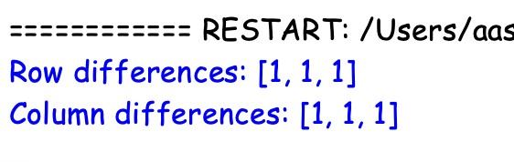

**5 . Minimum Penalty for a Shop** CODE : class Solution:

def bestClosingTime(self, customers: str) -> int:

n = len(customers)

min_penalty = float('inf') best_hour = 0 penalty_open = 0 penalty_closed = customers.count('Y') for hour in range(n + 1):

total_penalty = penalty_open + penalty_closed if total_penalty < min_penalty: min_penalty = total_penalty best_hour = hour

if hour < n:

if customers[hour] == 'Y':

penalty_closed -= 1

else:

penalty_open += 1

return best_hour

solution = Solution() print(solution.bestClosingTime("YYNY")) print(solution.bestClosingTime("NNNN")) print(solution.bestClosingTime("YYYY"))

OUTPUT :

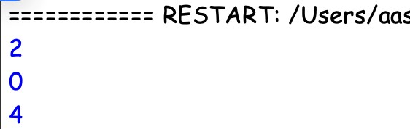

**6 . Count Palindromic Subsequences** CODE :

MOD = 10**9 + 7

def count_palindromic_subsequences(s: str) -> int:

n = len(s)

dp = [[[0 for _ in range(6)] for _ in range(n)] for _ in range(n)] for i in range(n): dp[i][i][1] = 1 for length in range(2, 6):

for l in range(n - length + 1):

r = l + length - 1 if length == 2: dp[l][r][2] = 2 if s[l] == s[r] else 0

elif length == 3: dp[l][r][3] = 4 if s[l] == s[r] else 0

elif length == 4:

dp[l][r][4] = 8 if s[l] == s[r] else 0

else:

if s[l] == s[r]:

dp[l][r][5] = (dp[l+1][r-1][3] + dp[l+1][r-1][4]) % MOD

result = 0 for i in range(n):

for j in range(i, n): result = (result + dp[i][j][5]) % MOD

return result

s = "12321" print(count_palindromic_subsequences(s))

OUTPUT :

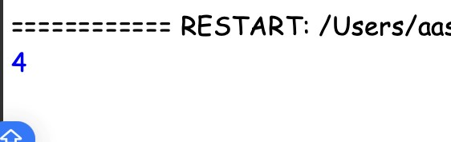

**7 . Find the Pivot Integer** CODE : def findPivot(n: int) -> int:

total_sum = n * (n + 1) // 2

left_sum = 0 for x in range(1, n + 1): left_sum += x right_sum = total_sum - left_sum + x if left_sum == right_sum: return x

return -1

n = 8

print(findPivot(n))

n = 4

print(findPivot(n))

OUTPUT :

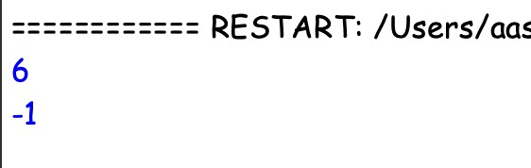

**8 . Append Characters to String to Make Subsequent** CODE : def min_chars_to_append(s: str, t: str) -> int:

m, n = len(s), len(t) i = 0 j = n - 1 while i < m and j >= 0: if s[i] == t[j]: j -= 1 i += 1

return j + 1

s = "abc" t = "bcab" print(min_chars_to_append(s, t))

s = "abcde" t = "aebc" print(min_chars_to_append(s, t))

OUTPUT :

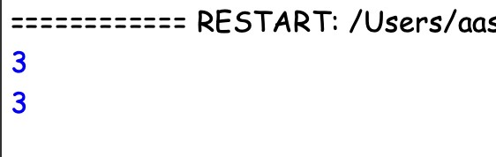

**9 . Remove Nodes From Linked List** CODE : class ListNode:

def __init__(self, val=0, next=None):

self.val = val self.next = next

def reverseLinkedList(head: ListNode) -> ListNode:

prev = None current = head while current:

next_node = current.next current.next = prev prev = current current = next_node

return prev

def removeNodes(head: ListNode) -> ListNode:

head = reverseLinkedList(head)

max_value = float('-inf') dummy = ListNode(0) dummy.next = head prev = dummy current = head

while current:

if current.val >= max_value: max_value = current.val prev = current else:

prev.next = current.next

current = current.next

head = reverseLinkedList(dummy.next)

return head

def printLinkedList(head: ListNode):

current = head while current:

print(current.val, end=" -> ") current = current.next

print("None")

head = ListNode(5, ListNode(3, ListNode(10, ListNode(7, ListNode(8))))) print("Original List:") printLinkedList(head)

new_head = removeNodes(head)

print("Modified List:") printLinkedList(new_head)

OUTPUT :

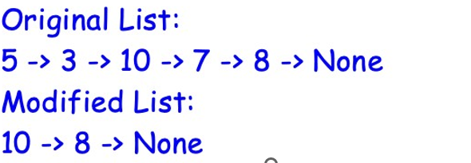

**10 . Count Subarrays With Median K** CODE : def countSubarrays(nums, k):

n = len(nums) count = 0

for i in range(n):

left = i right = i

while left >= 0 and right < n and nums[left] <= k <= nums[right]: if nums[left] == k or nums[right] == k:

count += 1 left -= 1 right += 1 return count

# Example usage nums = [1, 2, 3, 4, 5] k = 3

print(countSubarrays(nums, k))

OUTPUT :

